Brewster Middle School
Title I, Part A, Schoolwide Plan-School Improvement Plan
Title I, Part A : Schoolwide Program Model
Four Required Components:
☒ 1. Comprehensive Needs Assessment
☒ 2. Schoolwide Reform Strategies
☒ 3. Activities for Mastery
☒ 4. Coordination and Integration

Checklist for combined Title I, Part A Schoolwide Program Model
Is this plan:

☒ Based on a Needs Assessment
☒ Data driven
☒ Able to show continuous improvement by allowing the school or district to monitor, adjust, and update it
☒ Allowing active participation of and input from stakeholders

Does this plan contain under at least one of the components exposition of the following requirements:

School Improvement Plan; WAC-180-16-220,  Plan Requirements:  ☒ Annual Board approval  ☒ Proof the plan is data driven, promotes a  positive impact on student learning and offers a  continuous improvement process to monitor,  adjust, and update the SIP  ☒ The ways in which the model is based on a self-  review of the school’s program  ☒ The characteristics of successful schools  ☒ Equity factors for all students  ☒ The use of technology to facilitate instruction  ☒ Parent, family, and community involvement,  they relate to a positive impact on student  learning | ESSA: Sec.1111(d)(1)(B),  Plan Requirements:  ☒ Indicators of student performance against State-  determined long-term goals  ☒ Exposition of evidence-based interventions  ☒ Proof of a school-level needs assessment  ☒ Identification of resource inequities, which may  include a review of local educational agency and  school level budgeting, to be addressed through  the implementation of such comprehensive  support and improvement  ☒ Approval by the school, local educational agency  and State educational agency

COMPONENT #1: NEEDS ASSESSMENT
PROCEDURES TO SUPPORT YOUR COMPREHENSIVE PLAN
Plan What are we going to do? | Review disaggregated data (race, ethnicity, low income, SWD, 504, homeless and EL) with Building Leader team prior to taking it to the rest of the staff. Building Leadership team will define needs and strengths and share to get feedback from them.  Data:  - CEE: Each year we conduct a community needs assessment through Center for Educational Effectiveness (CEE) surveys, to gather staff, student and family input into our programs. The survey was administered during the spring 2018.  - Washington State Improvement framework: On the OSPI State report card this reflects how the Middle School performed based on the ESSA accountability Index. This also include the Smarter Balance Assessment data.  - Attendance – identify chronically absent students.  - Discipline – disaggregate student discipline data at the end of the first semester and again in June at the end of the school year to identify disparities.  - ELPA21 – Identify the EL students and where they are struggling and where they are making progress  - Parent Conference – Meet twice a year to go through student led conferences with the parent, teacher and student.
Do  When and how will we do it? | Sharp focus on rigorous, standards-aligned instruction  - Principal will increase his understanding of WA State Standards and NGSS and provide feedback to teachers about alignment of their Daily Learning Targets with Priority Standards  - Will complete Observation Cycle 1 by Nov 20, Cycle 2 by Jan 11 and Cycle 3 by Mar 23  Provide continuous, targeted feedback to teachers on their classroom practice  - Will complete 12 or more Classroom Walkthroughs weekly  - Will lead data analysis of the Walkthrough data with Leadership Team monthly  Monitor results of formative assessments to ensure teachers are getting 80% + students to meet identified priority standards with Tier I instruction (Monthly)  - ELA and Math teachers – IAB Calendar & Data Analysis  - SPED teacher: IABs for Math and ELA students  - EL teacher: IABs for EL students  - Science and Rotation teachers – Unit Assessment Calendar & Data Analysis  Monitor student learning outcomes (Monthly)  - AVID Study Teacher: LEXIA, ALEKS Math, Academic Vocab  - SPED Teacher: Read 180 and 7th Math Co-taught students  - EL teacher: AVID Study students  Monitor PLC Notes & Respond to Requests (Weekly)  - Grade level Teams Notes  - Look for collaboration with Sped and EL teachers  - Rotation Team, ELA, Math, Science Teams  Monitor Attendance (Weekly)  - Participate in Tier II and Tier III Student Meetings  Monitor SWIS Data (Monthly)* Grade level Teams Notes  - Look for collaboration with Sped and EL teachers  - Rotation Team, ELA, Math, Science Teams  Monitor Attendance (Weekly)  *Participate in Tier II and Tier III Student Meetings  Monitor SWIS Data (Monthly)
Study What were the results? | 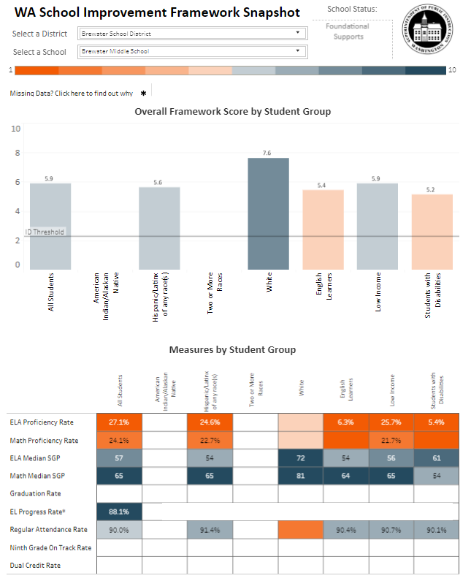  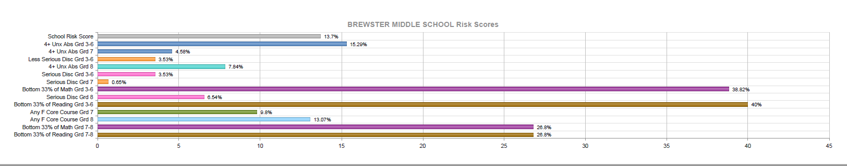  Strengths that contribute to the success of this plan:  - Dedicated staff willing to make changes and adjustments in order to get the desired results.  - Student buy in with our plan to not only increase proficiency but the culture of our school, which was needed in order to get moving in the right direction.  - Staff that has a growth mindset  - 100 percent attendance rate for parent and students at the Fall student led conference  Challenges that we will need to monitor:  - The way the State misguides us with IAB results and the use of “at or near”.  - Proficiency scores
Adjust  What changes are we going to make based on our findings | Progress Monitoring: Used for placement of individual students during PLC collaboration time based on teacher’s recommendations, IAB data, unit assessment data. Adjustments are made to the intervention and student list, daily lesson and after’s program.  Continue to monitor IAB results and Unit Assessment results in a timely fashion. We have our entire staff sit down and grade the brief write at each grade level. Unit assessment paper work is turned into the principal after each assessment.  Parent Conference survey: Adjusting it to get a better feel and useful information for what parents and students.
COMPONENT #2: SCHOOLWIDE REFORM STRATEGIES
PROCEDURES TO SUPPORT SCHOOLWIDE REFORM STRATEGIES
Plan  What are we going to do? | Parent and family engagement:  - Have parent advisory group put together a parent survey. Come up with questions that parents can understand and meaningful as well. Will then run by the leadership team for input. A letter will be sent home to parents by the third week in December asking for volunteers to be on the parent advisory board. Names will be collected and the parent advisory will meet on January 31 2019.  - Attendance – Working with the counselor on ways we can improve in this area. Giving out perfect attendance awards at our monthly assemblies is something we have started as well letting parents know through our family liaison.  Professional Development  - Differentiation/Scaffolding – We use the ESD staff to come into our building for training  - Focused Strategies (AVID, GLAD, PBIS) – AVID conferences in the summer. GLAD strategies for groups and individuals. PBIS team will meets every other Tuesday to discuss what is working or what needs to be tweaked. We will also do our PBIS matrix walks with all students after each major break in our school calendar.  - Standard Based Grading – Use the ESD staff and our high school staff to help lead the way for a smooth transition
Do  When and how will we do it? | Parent and family engagement:  - Parent walk through with administration using a walk through tool that will be explained at a briefing before the walk through takes place and a debriefing afterwards.  - Attendance – Working with parents of those that have attendance issue. Letting parents know that education of their child is affect each and every day they miss school. We have children that will miss anywhere between five and twenty days during the winter as children are pulled from our school as the family heads south for jobs or family.  Professional Development  - Differentiation – Kate Lindholm from the ESD is scheduled to train the staff at a late start Monday.  - Focused Strategies (AVID, GLAD, PBIS) - AVID conferences in the summer have been attended by each staff member over the years. GLAD strategies are taught by ESD staff, who not only work with groups, but individual staff as well. PBIS team meets every other Tuesday to discuss what is working or what needs to be tweaked. Matrix walks for PBIS our scheduled out so that each student will cover the 8 areas we have chosen are the build and campus.  - Standard Based Grading – We are making the move to standard base grading next school year (2019-20) and have used the ESD staff and our own high school staff to help us make this transition.
Study  What were the results? | Parent and family engagement:  - Review the results of the survey as well as parent input from the advisory committee.  - Attendance We have seen a slight increase in attendance since doing the perfect attendance awards at our assemblies  Professional Development:  - Differentiation – Staff using the tools they learned on a consistent basis.  - Focused Strategies (AVID, GLAD, PBIS) – The introduction of AVID and PBIS into our school has changed the culture of who we are and where we would like to go. PBIS alone has help drop our discipline numbers from the 600-700 annually to less than thirty (major offences). AVID strategies are seen in each classroom. Each student uses a 3 inch, three rind binder that will hold material for each of their classes in an organized way.  Standard Based Grading – have not implemented it yet  Strengths that contribute to the success of this plan:  - Built a strong foundation with a staff that is willing to make the changes that are necessary in order to reach the goal we have set for ourselves.  - District provided embedded and targeted professional development for all staff that is responsive to specific needs.  - Our school schedule which allows daily collaboration among grade level staff as well as having built in intervention/enrichment opportunities for all students.  - Late start, district wide Monday, allows for vertical collaboration not only with in our building but allows us to collaborate with elementary and high school staff in areas of English language arts, science, math and rotation subjects.  - Actions put into place over the past few years has resulted in a stronger attendance rate among the students.  Challenges that we will need to monitor:  - Needing more knowledge surrounding standard base grading to fully implement.  - Keeping staff from wandering away from the direction and goals we have set.  - Celebration with staff when goals are reached and milestones reached.
Adjust What changes are we going to make based upon our findings? | - Focused Strategies (AVID, GLAD, PBIS) – We will continue to focus in these areas of PBIS, AVID and the use of GLAD strategies as each one of these has become a major part of Brewster Middle School. Our culture is wrapped around these and we feel good that we are heading in a good direction with these areas helping build a strong foundation.  - Attendance – We need to educate our parents more of the importance of attendance and a successful education. We have let parent know that when they pull students from school to head south for work or visit family member, that we will file on them after ten days of absence, if they do not check into a school at their destination.  - Standard Based Grading – Using our curriculum guide to help shape the standards in the grade book seem to be a challenge for us at this time. Using Skyward does not seem to be friendly when it comes to Standard Base Grading and entries.
COMPONENT #3: ACTIVITIES TO ENSURE MASTERY
PROCEDURES TO SUPPORT YOUR ACTIVITIES TO ENSURE MASTERY
Plan  What are we going to do? | Standard Based Grading: To ensure mastery of the State Standards. We are being introduced to Standard Base Grading by local ESD staff as well as high school staff who are already using it. We need to understand how it will show a clearer growth in certain areas and if growth is being made as well as if the students have met the standards.  PLC collaboration time: Staff will meets for at least 150 minutes a week to review progress of students and determine instructional adjustments that need to be made.  High School and Beyond Plan – Starting in Advisory class which meets every Monday we will begin the HS and Beyond Plan by using My School Data.
Do  When and how will we do it? | Standard Based Grading: Continue to educate ourselves with the process of SBG and how it will look in Skyward, our grading system. We have already started the process of looking into SBG.  - 2017-18 school year staff began exploring SBG  - The math team started piloting in the 2017-18 school as it was a better fit for their team to move forward.  - The other teams (ELA, science, rotation) needed more understanding of the process and are still looking into the ramifications it will have on them, with the intent all teachers using SBG starting in the fall of 2019.  - We invited two high school teachers to a late start Monday meeting to explain how they are using the process and to answer our questions to better understand. (October 29 2018)  PLC collaboration time: Collaboration time is built into the everyday schedule. Grade levels all have the same prep/collaboration time, which allows them to meet as a group.  High School and Beyond Plan – The work will begin In mid-January 2019, after staff has been introduced to the process and My School Data tool. We will also work with the high school counselor as most of the information will come at a later date (high school). We will start the tool by entering “Who are you?”, “What would you like to do as a profession?” and “How will you reach your goal?”
Study What were the results? | PLC collaboration time: The results are in the way the staff works together to solve problems, work out solutions, talk about individual student or simply talk to one another. I have noticed a better comradery among my staff as they work out solutions as a team instead of as an individual.  High School and Beyond Plan – With the addition of a new counselor this year and the absence of on last year, we are planning to get this up and running prior to the end of the calendar year. It will be ready to share with parents for the Spring conferences.  Strengths that contribute to the success of this plan:  - Built a strong foundation with a staff that is willing to make the changes that are necessary in order to reach the goal we have set for ourselves.  - District provided embedded and targeted professional development for all staff that is responsive to specific needs.  - Our school schedule which allows daily collaboration among grade level staff as well as having built in intervention/enrichment opportunities for all students.  - Late start, district wide Monday, allows for vertical collaboration not only with in our building but allows us to collaborate with elementary and high school staff in areas of English language arts, science, math and rotation subjects.  - Actions put into place over the past few years has resulted in a stronger attendance rate among the students.  Challenges that we will need to monitor:  - Needing more knowledge surrounding standard base grading to fully implement.  - Keeping staff from wandering away from the direction and goals we have set.  - Celebration with staff when goals are reached and milestones reached.  - Making sure that each student has a high school and beyond plan started by using the My School Data dashboard.
Adjust What changes are we going to make based on upon our findings? | PLC collaboration time: Maintain consistency with sharing collaboration notes with administrator after each meeting.  High School and Beyond Plan – Every student will have a profile and know how to access the information as well as Advisory Staff.
COMPONENT #4: COORDINATION AND INTERGRATION
PROCEDURES TO SUPPORT YOUR COORDINATION AND INTEGRATION OF SERVICES
Plan  What are we going to do? | Program Amount Available How the Intents and Purposes of the Program will be Met  Title I, Part A $51,850 In-school interventions targeted to specific student academic needs, small group instruction designed to help students meet benchmark goals.  Basic Education & Local Funds $1,427,644 All students receive instruction aligned to state standards, late start Monday training & collaboration time, after school program  LAP High Poverty $66,780 Intervention support, extended day, embedded professional development  Total $1,546,274
Do When and how will we do it? | Students will be identified for additional support based on needs, using SBA and IAB results, classroom-based assessments and teacher recommendations. Title I Schoolwide funds will support the AVID class to provide students with strategies to increase success in school and embedded professional development to help staff improve targeted instructional skills and more effectively utilize Professional Learning Communities (PLCs) to meet student needs, as well as time to collaborate. Extended day student support will also be provided.
Study What were the results? | As the program is monitored during the year (Building Leadership Team, PLCs, survey results, assessment results, etc.), information will be gathered to evaluate successful implementation and student outcomes.
Adjust What changes are we going to make based on upon our findings? | Through annual program monitoring during the year and evaluation each fall, strengths and needs will be identified and adjustments made based on data during the needs assessment updates for 2019-20.

